Project Design Phase-II
Technology Stack (Architecture & Stack)

Date | 4February 2026
Team ID | LTVIP2026TMIDS66672
Project Name | Heart Disease Analysis Using Tableau
Maximum Marks | 4 Marks

Technical Architecture:
The Deliverable shall include the architectural diagram as below and the information as per the table1 & table 2

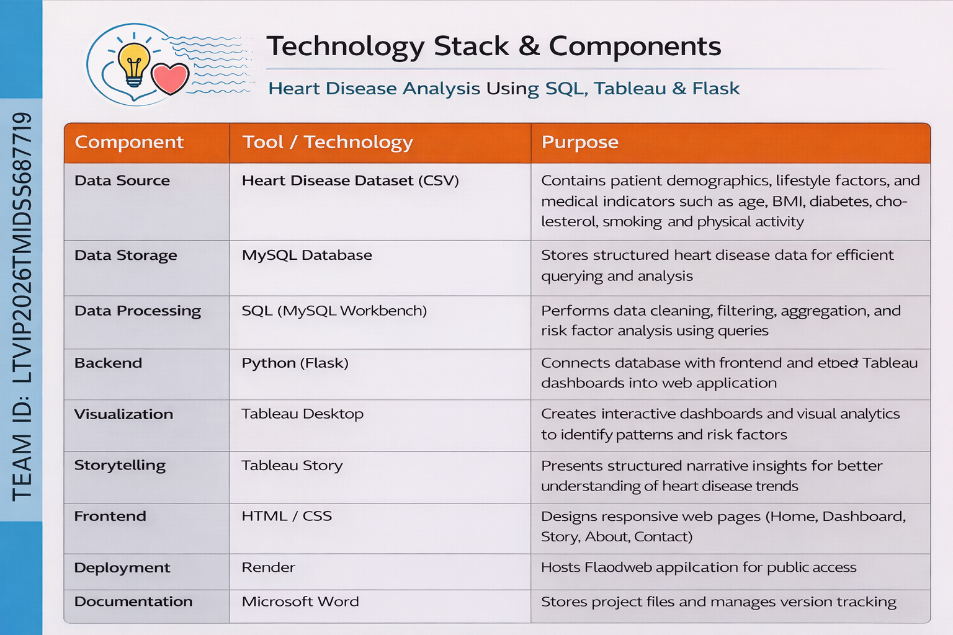

Table-1 : Components & Technologies:
S.No | Component | Description | Technology
1 | User Interface | Interface through which users interact with heart disease dashboards and stories via a web browser. | HTML, CSS, JavaScript
2 | Application Logic – 1 | Backend logic for handling web requests and embedding Tableau dashboards. | Python (Flask)
3 | Application Logic – 2 | Data processing and SQL-based data preparation logic. | SQL, MySQL
4 | Application Logic – 3 | Data visualization and analytics logic. | Tableau Desktop, Tableau Public
5 | Database | Stores heart disease dataset including demographic, lifestyle, and clinical data. | MySQL
6 | Cloud Database | Optional cloud-based storage for published dashboards and data access. | Tableau Public
7 | File Storage | Storage of dataset files, Tableau workbooks, and project assets. | Local File System
8 | External API – 1 | Embedding Tableau dashboards into web application. | Tableau Embed API
9 | External API – 2 | Not applicable for this project. | N/A
10 | Machine Learning Model | Not implemented in this project. Analysis is visualization-based. | N/A
11 | Infrastructure (Server / Cloud) | Deployment environment for web application and dashboards. | Local Server (Flask), Tableau Public

Table-2: Application Characteristics:
S.No | Characteristics | Description | Technology
1 | Open-Source Frameworks | Lists the open-source frameworks used for developing and integrating the web-based dashboard application. | Python (Flask), HTML, CSS, JavaScript
2 | Security Implementations | Ensures secure access to data sources and dashboards. Database credentials are protected, and secure embedding practices are followed. | MySQL Authentication, Secure Credentials Handling, OWASP Best Practices
3 | Scalable Architecture | The system follows a modular, layered architecture where data storage, analytics, and presentation layers are separated, allowing future expansion. | 3-Tier Architecture (Database – Tableau – Web UI)
4 | Availability | The application ensures high availability through published dashboards and web-based access, minimizing downtime for users. | Tableau Public, Local Web Server
5 | Performance | Performance is optimized through efficient SQL queries, limited data rendering, and interactive filters that reduce processing load. | SQL Query Optimization, Tableau Filters

